LOVER COMMUNITY TRUST (LCT)
Annual General Meeting 2022
Date: Monday 8th November |  | Time: 7.30pm | Venue: The Old School Building (OSB)
35 Members of the Trust were present, plus 2 participating via Zoom. List of attendees and apologies held by LCT Secretary, Marilyn Dollard

Welcome from the Chair | The Chair, Nick Gibbs, welcomed members to the meeting and also extended a welcome to new members of LCT who had joined during the year.
Chairperson’s Report | The Chair presented his report, a copy of which is attached.  There were no questions from those attending.
Treasurer’s Report | The Treasurer, Peter Harper, presented his report on the year to 31.12.2021. A copy of his report, along with the financial statement for the year, is attached.  The Treasurer was asked what measures users were being asked to take in response to the large increase in energy costs. He responded that by and large they were being asked to adopt the same measures as they would in their own homes, such as having the heating on at a lower setting, closing doors and windows as far as is practicable, and making sure the heating was turned to the frost setting when the building is not in use. Notwithstanding these measures it is anticipated that hire charges would need to be increased substantially when the trustees review them in December, and even then they would probably be insufficient to cover the cost of heating in winter months if prices remain at their current level.  In response to a question from the floor about income and expenditure to date in 2022, he stated that:  - Hall hire income had picked up following the pandemic and was on an upward path. It was likely to exceed £5000 by year end, compared to £2330 in 2021.  - Fundraising was likely to be approximately £2000 higher than in 2021, thanks to another successful Valentines campaign and the reinstatement of the Lover Country Fayre.  - Grants would be lower: one final Government Covid-19 support grant of £2667 had been received but currently no further grant applications are in place.  - Other income sources (membership fees, donations, reward schemes and Gift Aid) would likely be in line with previous years.  - Day to day expenditure would mainly be in line with previous years, with the exception of energy costs, with gas prices having increased substantially in October as outlined in the main report
Lover Green Report | The Chair of Lover Green Subcommittee presented her report, a copy of which is attached.  There were no questions from the floor.
Election of Trustees | Three Trustees retired by rotation: Mar Copp, Nick Gibbs and Mar Copp. Having indicated their willingness to serve a further term as trustees they were duly re-elected.  Alison Clarke, who had been co-opted during the year on taking up the role of Chair of the Lover Green Subcommittee, was also elected as a trustee.  Graham Budworth, Dave Charles, Marilyn Dollard and Rob Easton also remain as trustees.  No other nominations for trustees had been received.
Resolutions | The following resolution had been submitted before the meeting:  “It is resolved that the front studio room at the Old School will formally be known as ‘The Queen Elizabeth Room’ with immediate effect in honour of Her Late Majesty”  The resolution was seconded and agreed unanimously.
AOB | Various members present added their thanks to volunteers who had assisted with the maintenance of the building and Lover Green, and with events held over the year. Special thanks were voiced for the hard work put in by the Chair.  A member asked whether there were any plans to celebrate the Coronation of King Charles III in 2023. Several suggestions were made, including that a TV Licence be purchased so that the Coronation could be screened in the building, and that the café should operate for the event. It was also suggested that coronation events should be coordinated between organisations in the village. These suggestions will be taken forward by the trustees at a future meeting.
Conclusion of Meeting | The meeting finished with a slide show showing the various stages of the transformation of the building during its refurbishment. The formal meeting closed at 8.30 pm.
Date of Next Meeting | Meeting of the Trustees: Wednesday 14th December 2022 @ 10.30 am  at the Old School Building

LOVER COMMUNITY TRUST
AGM CHAIRMAN’S REPORT
7TH NOV. 2022
Dear Members and Friends
It was almost 10 years ago that we decided, as a village community to acquire our redundant primary school in order to bring it back to life as a centre of activity to serve all those that live in the wider locality. Much has been achieved from those beginnings and we can all be proud of what we have achieved over the intervening period.
We have been held back, but not defeated, by both foreseen and unforeseen circumstances. We did foresee that available funds would always determine the speed of refurbishment but we have proceeded far quicker than we thought possible. The unforeseen circumstances of the pandemic and now the economic crisis, present challenges but we are working hard to face up to them.
We have made huge changes to the building and now have planning permission to create a new entrance and toilet facilities, which when finished, will allow us to fully open to the use of all facilities. Plans will be on view at the AGM for you to view. We also have retrospective jobs to do in reducing sound reverberation in the Valentine Room. When it is all completed the organisation of a full and lively community programme will start in earnest. To achieve it the Trust is going to need an Events Group charged with the responsibility of coming up with ideas and facilitating their implementation. The Trust is looking for people that would be interested in helping with that task. CAN YOU HELP?
Recently the Trust formally submitted a report to the Parish Council outlining the increasing problem of village parking that results from events at their Redlynch Village Hall, The old School, Lover Green and St Mary’s church. The report ( which is available on our website ) sought to get the Parish Council to merely begin the discussion by convening a meeting to start the discussion to which all the relevant agencies would be invited. However, the Parish Council chose not to do that so the matter will now be left for other statutory agencies to deal with as they see fit.
As those of you who attended last year’s AGM will be aware, our policy has been not to allow parking on Lover Green except in extremely limited circumstances such as for stallholders setting up for the Lover Fayre, where we can control what happens. However, as a result of feedback from the community and following a recommendation from the Lover Green sub-Committee we are now looking into a strictly weather dependant scheme to provide parking for funerals. This is also dependent on a having procedures in place to ensure that parking is adequately supervised and that our concerns regarding safety to the public (especially children) and damage to the Green are addressed. Provided that this can be agreed with the relevant organisations, we should be in a position to approve a proposal at our next meeting in December.
Each year the Board expresses its thanks to all the volunteers that do so much in assisting our work and, of course, this year is no exception. We are truly lucky to have such wonderful support from the community. We avoid mentioning people by name as there are so many but it includes:
- The Darlings and Cupids on the Valentine Post and Darling Café
- Painters| and cleaners
- Architect/building group
- Technology backup
- Public Relations Group
- Neighbours
- Members
- .Lover Green Committee
- Lover Community Trust Board and Office Bearers.

I would particularly like to mention all the members of the Trust for their great show of faith in the developing project. We were pleased to welcome a new Chair of the Lover Green Committee this year, Alison Clarke and she has also joined the Trustees.
The Trust Board is well aware of the length of time the project is taking to get to completion but almost all the Members have stuck with us. We are looking forward to the time when we are running a lively and all embracing programme for the community we serve.
Thank you all for you continuing patience and support.
Nick Gibbs
Chair
Lover Community Trust

Lover Community Trust
Treasurer’s report 2021
Looking at the figures, it is hard to believe the constraints we were working under for most of 2021 as a result of COVID restrictions. There was only limited opportunity to generate hire fees, since we were not fully re-open for hire until October 2021. Fund raising was limited to on-line events. Nevertheless we made up for it in other ways. The Valentine Post, operating online only, raised a magnificent £11 634. We benefited from further government COVID grants to the Hospitality and Leisure sector of £16 731, and we were awarded a grant of £5000 by the Bernard Sunley Foundation towards the refurbishment programme.
With the building not being used, utility costs were down, although many day-to-day costs such as insurance remained at the same level as in a ‘normal’ year. The major area of expenditure however was on the refurbishment of the building, which pressed ahead taking advantage of the lack of hiring. The figure of £66 860 covers the completion of work on the Valentine Room, followed by installation of our new kitchen. We also spent £966 on the maintenance of Lover Green, in line with previous years (this does not include £1000 from Redlynch Parish Council under their Asset Grant scheme which paid for tree work and a security bollards at the Church Hill entrance).
We ended the year with reserves of a little over £38 000, of which just over £20 000 is ‘ring fenced’ in restricted and designated funds, the remainder being available to fund the next phase of the refurbishment project.
Looking ahead, so far the position in 2022 remains healthy from a financial perspective. However one big cloud on the horizon is the rise in energy costs. We have a fixed price contract for electricity until October 2023. But our gas contract ran out on October 18th and we are now paying eight times the previous rate. We are facing bills of £4000 or more (after government relief) compared to the £700 or £800 it has cost in recent years. I would implore hall users to be sensible with the use of heating and it a certainty that we shall have to increase hire charges in the New Year.
Peter Harper – Treasurer, Lover Community Trust

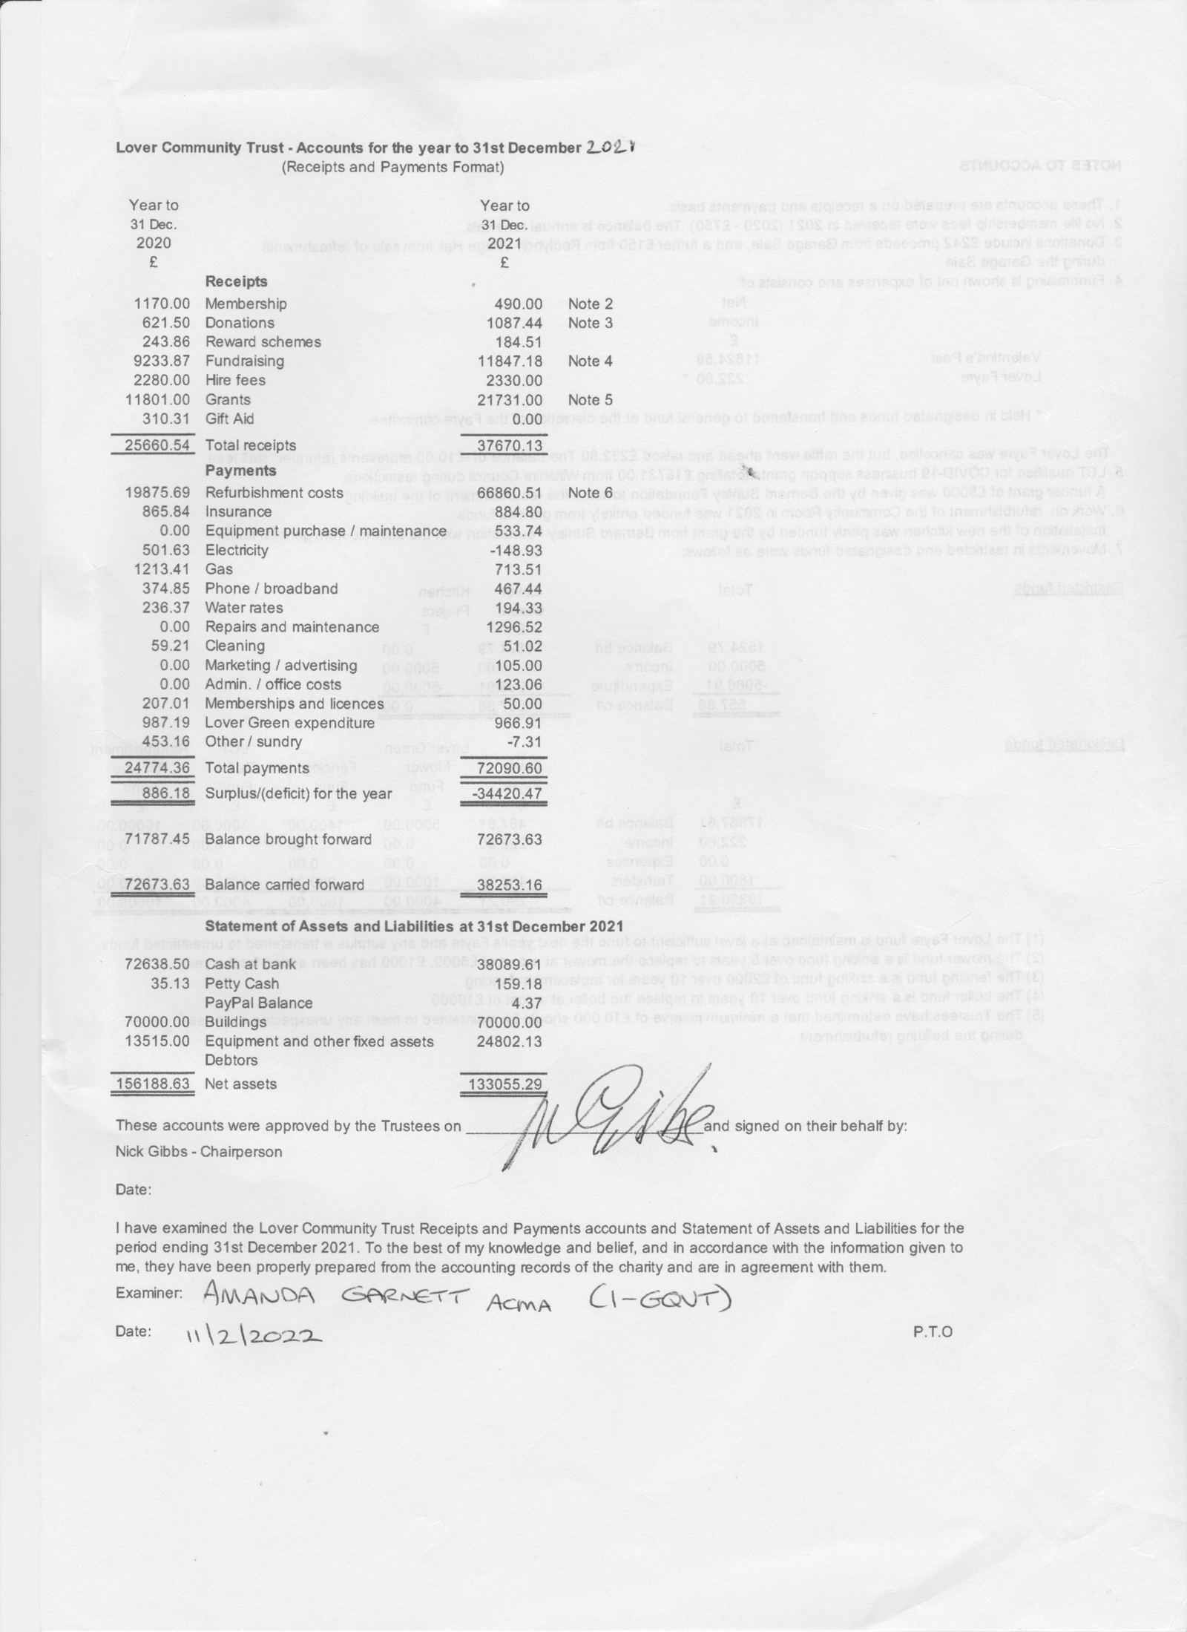
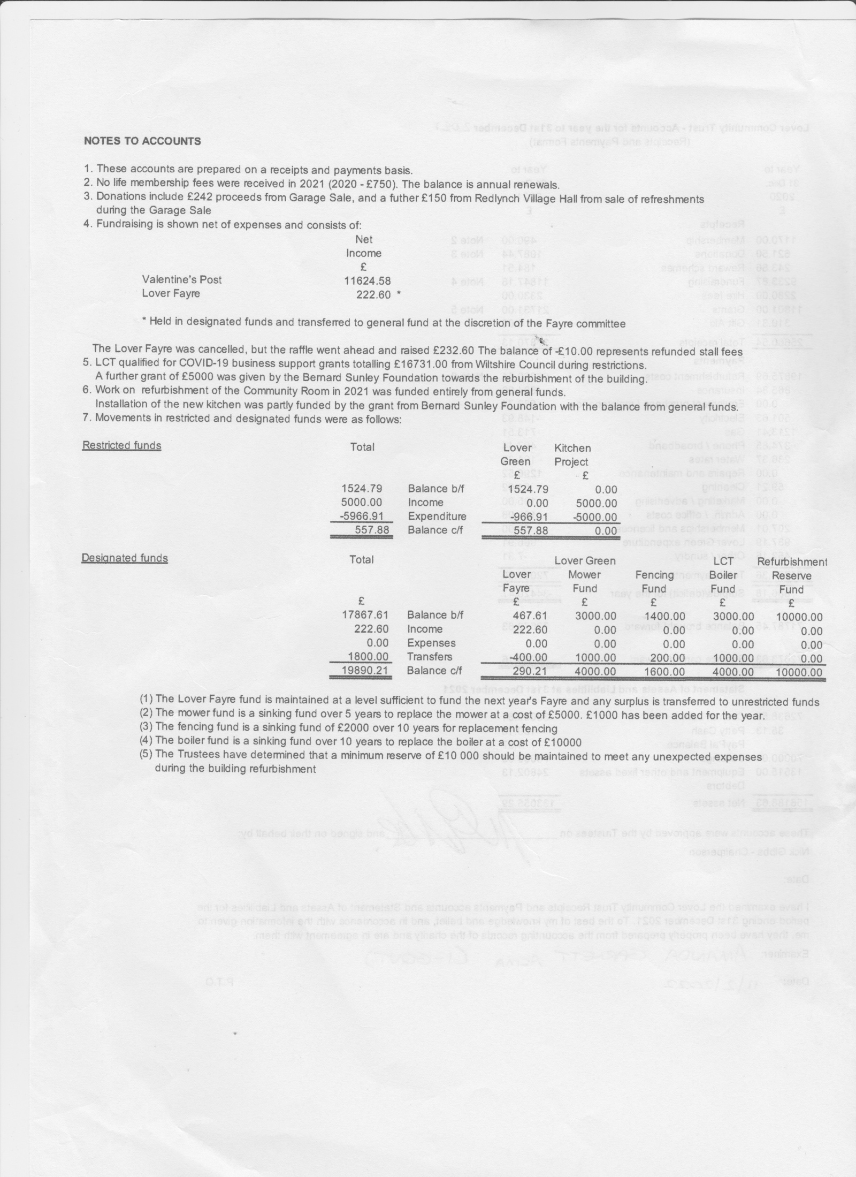

LOVER GREEN REPORT – 7 Nov 2022
Firstly, on behalf of the Lover Green committee, I would like to thank Dave Charles for his work over the years on the Green and on the Lover Green Committee. We would also like to thank anyone who helps us or supports us in any way.
Maintenance on the Green in 2021 included getting Tree Menders to cut back the hedge along Church Hill which was growing onto the road. Also, we hired a digger so that an area could be banked and grassed over. There was a working party to remove a wooden fence from alongside the playground which was falling apart and becoming hazardous. (many thanks to Rachel for these details)
We have been busy on Lover Green during 2022.
Our 2021/2022 application for a Parish Council Grant was successful and the money was spent on a new roof for the Pagoda in March. We also had the broken sides of the Pagoda repaired and gave it a fresh coat of paint.
The goal posts on the Green have been refurbished and gleam white once more.
A rowan sapling was planted as part of the Queen’s Green Canopy for the Platinum Jubilee 2022. There was a planting ceremony with Lover & Redlynch Preschool and the children enjoyed watering the new tree and singing the National Anthem. Albeit small, the tree is doing well.
The barked area by the flower beds had become an unsightly area of scrub. This has now been cleared, covered with topsoil and the recently sown grass seed has already developed a lovely green haze. Going forward it should be easier to maintain although it will give Bill even more grass to mow.
The grass is routinely mowed and the orchard regularly weeded. If anyone has any expertise in pruning fruit trees, we would appreciate your advice.
Tree Menders have just carried out some overdue tree and hedge work for us, to improve tree health and keep the Green safe to use. You may have noticed the Tree Maple just outside this building has been pollarded. One side had died back but it was important not to lose the tree as it adds to species diversity on the Green. Pollarding should generate healthy new growth.
Planning ahead, Tree Menders are already booked to survey our trees again next May.
Work on the flower beds has now started. Although weather dependent, tending the flower beds generally happens fortnightly on a Tuesday morning to tie in with the green bin collection. If anyone ever has any free space in their green bin, I would be happy to fill it.
You may have seen our first Newsletter in the October issue of the Parish Magazine. We intend to contribute an article perhaps quarterly or when there is something of note to report.
We have some key projects going forward. The committee has a “Can Do” mentality, but we are a very small group and have limited labour to get things done. We could really benefit from some help.
We would like to reinstate the gravel path that runs round the Green, as this has become weedy and less defined. The pond area needs a lot of work as it has become very overgrown and we want to build some compost bays for compostable green waste. Other projects are bound to crop up too.
We are looking to have a Working Party to have a general tidy up sometime after Easter and will publicise the dates nearer the time in the Parish Magazine and via the Lover Community Trust email.
If you can spare an hour or so from time to time, please get in touch. You can email me, or you can tell any one of our committee members. We are Rachel and Bill Jones, Jill and Fred Stark, Peter Harper, Mar Copp, Ros and Tom Cunliffe, Simon Voss, and myself.
The Lover Green committee is very proud of our community space and we work hard to maintain it. Please help us to keep it looking good.

